**1. Histogram**

Histogram created for Influenza death raw data, in data suppressed death value is replaced by range of 0 to 9(as per your feedback) by =RANDBETWEEN(0,9). Also size of bin adjusted for proper understanding.

Ages are grouped and proper color schema are made to histogram plots.

As histogram won’t allow sorts so it’s difficult to see in this wide range, 85+ having more Vulnerable(more death) than young population.

All Age groups have death.

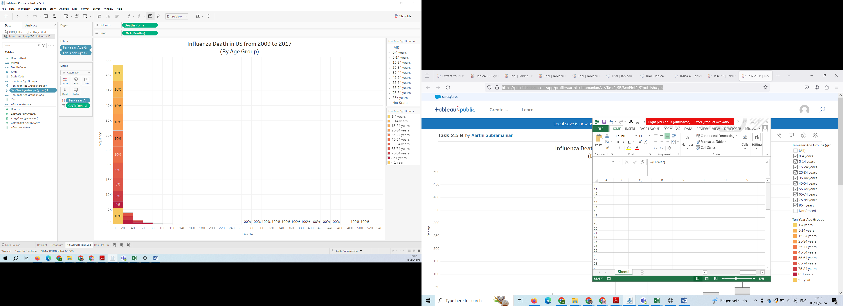

<https://public.tableau.com/app/profile/aarthi.subramanian/viz/Task2_5c/HistogramTask2_5?publish=yes>

**2. Box Plot**

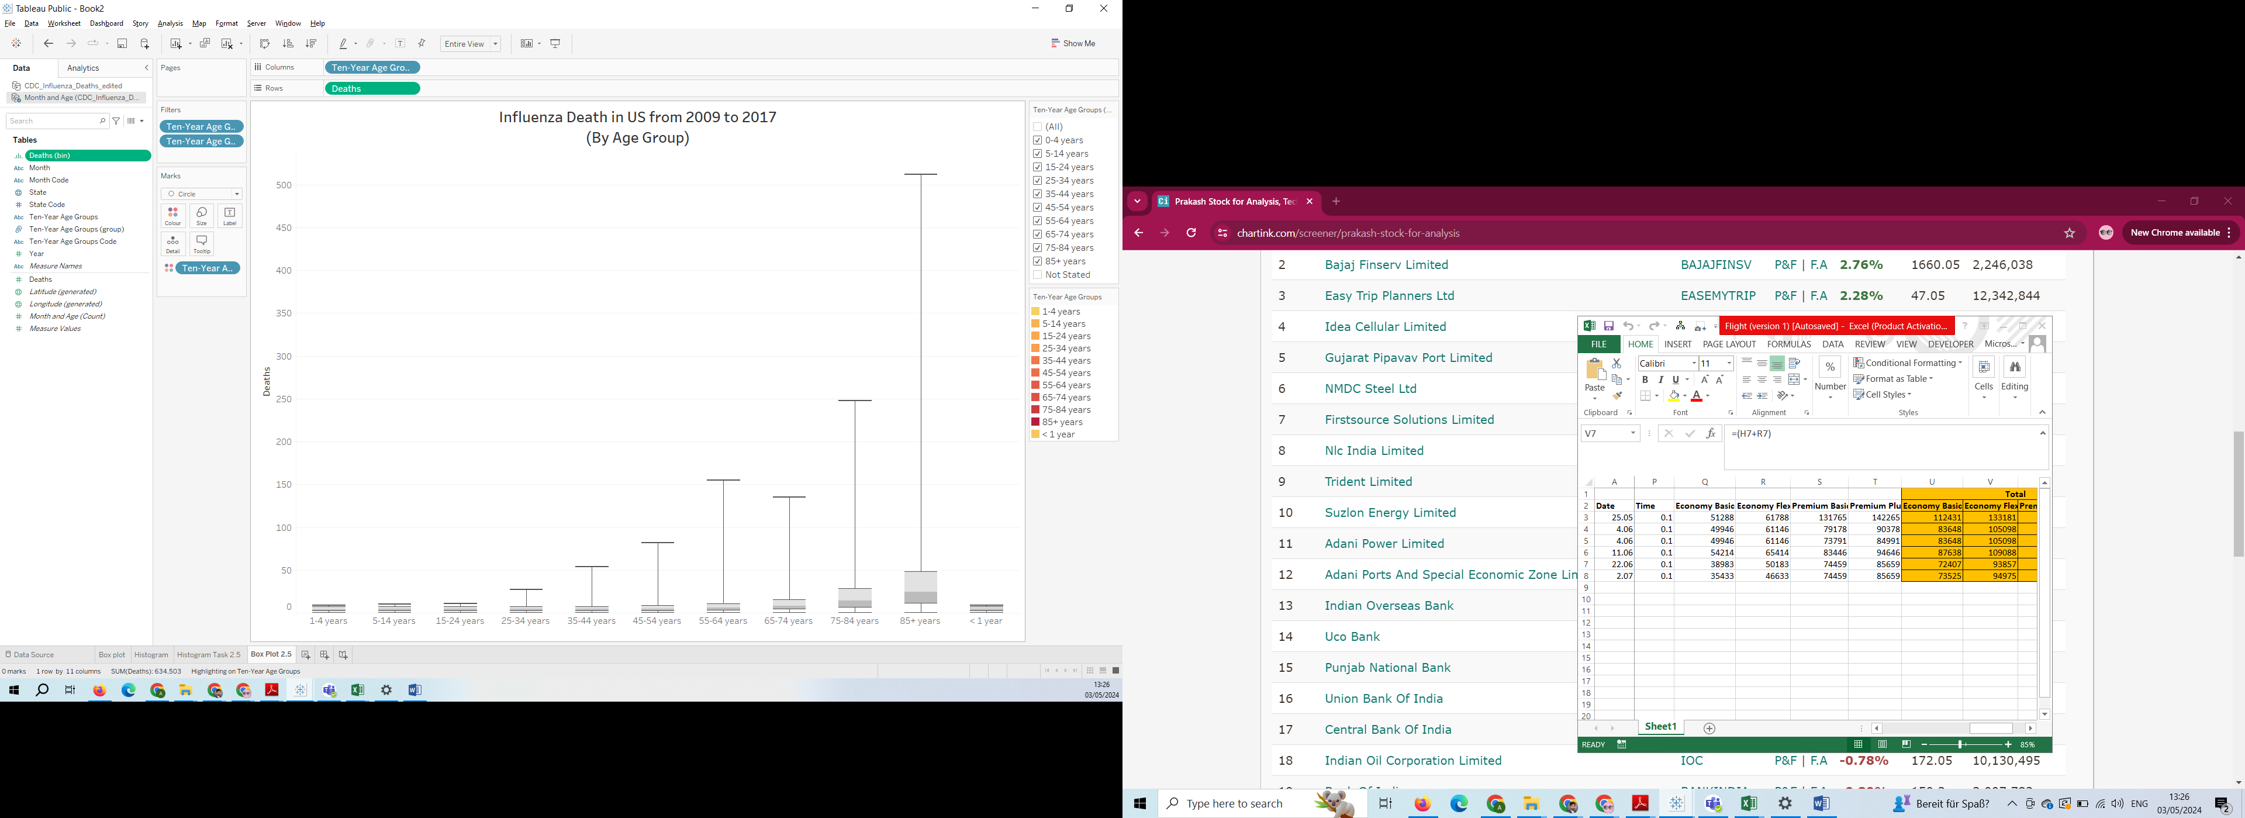

<https://public.tableau.com/app/profile/aarthi.subramanian/viz/Task2_5B/BoxPlot2_5?publish=yes>

3.

|  |  |  |  |
| --- | --- | --- | --- |
|  | **Checklist** | **Histogram** | **Box Plot** |
| **Text** | 1) Are the title and text descriptive enough? (i.e., do you understand what the visualization is trying to convey just by looking at the title and text?) | Yes by looking at we can assume this has influenza death by age group | Yes by looking at we can assume this has influenza death by age group |
| 2) Are there text labels? | yes | No only x axis |
| 3) Does the text portray any redundant information that could be gotten rid of? | no redundant information | no redundant information |
| 4) Do colors, shapes, and size scales come with legends? | yes color come with legend | No , here color not necessary |
| **Color** | 1) What does the color scheme signify? | Color schema signify age group from 0 to 85+ | N/A |
| 2) Are there more than five colors? | yes having 11 colors | N/A |
| 3) Does the color scheme make sense? Are colors analogous, complementary, monochromatic, or intuitive? | yes this applicable for age wise from light shade to dark | N/A |
| 4) If color is used to draw attention to important information, is the darkest color representing the most important information? | yes darkest color signify aged population | N/A |
| **Other** | 1) Are different sizes used? If so, is there meaning behind the sizes? | No , column size depends on death frequency | No , size based on frequency of death |
| 2) Are there groupings in the data that can be portrayed through color, size, or position? | yes age grouped by colors | yes age grouped by colors |
| 3) Is there (enough) whitespace? | yes | yes |
| 4) Is the visualization accessible? | yes | yes |
| 5) Does the visualization teach you something? | Yes, the histogram shows that older age groups have a greater frequency of influenza related deaths | Yes, the box plot shows that older age groups have a greater median frequency of influenza related deaths |

4. Unlike the histogram, the box plot shows median and quartile values for each of the age groups.